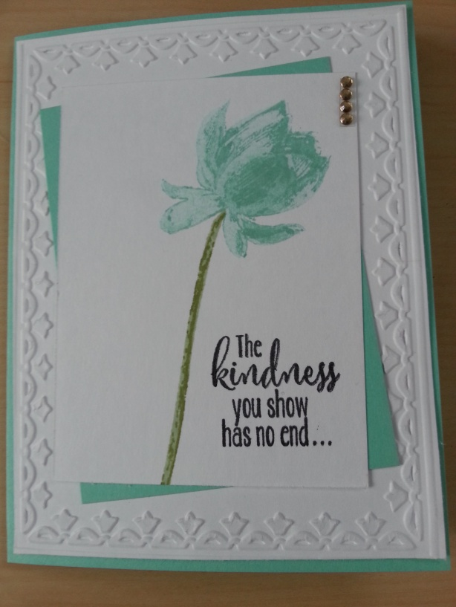
Supplies  Whisper White Card Stock  Costal Cabana Card Stock  Costal Cabana Ink Pad  **Stem Inks  Basic Black Ink Pad  Lotus Blossom Stamp Set  Framed Tulips Embossing Folder  Rhinestone Basic Jewels | Card Measurements  Card Base 5 1/2 X 4 1/4  Small Whisper White Layer 3 X 4  Costal Cabana Layer 3 X 4  Large Whisper White Layer 5 5/16 X 4 1/16 (x2)  Essential Supplies  Big Shot  Snail Adhesive  Simply Scored  Clear Mount Stamp Blocks  Stampin’ Scrub and Stamp Cleaner

Instructions
- Stamp Lotus Blossom in Costal Cabana Ink & Stem in XXX Ink on Small Whisper White Card Stock using Single Color Instructions provided
- Stamp greeting from Lotus Blossom Stamp Set beside stem
- Adhere Whisper White Card Stock to Costal Cabana Card Stock with Snail Adhesive
- Put Large Whisper White Card Stock in Framed Tulips Embossing Folder and run through Big Shot
- Adhere Embossed Whisper White Card Stock to card base with Snail Adhesive
- Adhere Costal Cabana & Lotus Blossom to Embossed Whisper White Card Stock with Snail Adhesive
- Attach Rhinestone Basic Jewels to top layer
- Adhere second Large Whisper White Card Stock to inside panel of card with Snail Adhesive
- Stamp ‘Thank You’ from Lotus Blossom Stamp Set inside card in Basic Black Ink

